Case Study 1: Job Data Analysis
You will be working with a table named job_data with the following columns:
- job_id: Unique identifier of jobs
- actor_id: Unique identifier of actor
- event: The type of event (decision/skip/transfer).
- language: The Language of the content
- time_spent: Time spent to review the job in seconds.
- org: The Organization of the actor
- ds: The date in the format yyyy/mm/dd (stored as text).
CREATE DATABASE project3;
USE project3;
CREATE TABLE job_data (
ds DATE,
job_id INT,
actor_id INT,
event VARCHAR(50),
language VARCHAR(50),
time_spent INT,
org VARCHAR(5)
);

INSERT INTO job_data (ds, job_id, actor_id, event, language, time_spent, org) VALUES
('2020-11-30', 21, 1001, 'skip', 'English', 15, 'A'),
('2020-11-30', 22, 1006, 'transfer', 'Arabic', 25, 'B'),
('2020-11-29', 23, 1003, 'decision', 'Persian', 20, 'C'),
('2020-11-28', 23, 1005, 'transfer', 'Persian', 22, 'D'),
('2020-11-28', 25, 1002, 'decision', 'Hindi', 11, 'B'),
('2020-11-27', 11, 1007, 'decision', 'French', 104, 'D'),
('2020-11-26', 23, 1004, 'skip', 'Persion', 56, 'A'),
('2020-11-25', 20, 1003, 'transfer', 'Italian', 45, 'C');

Select* from Job_data;
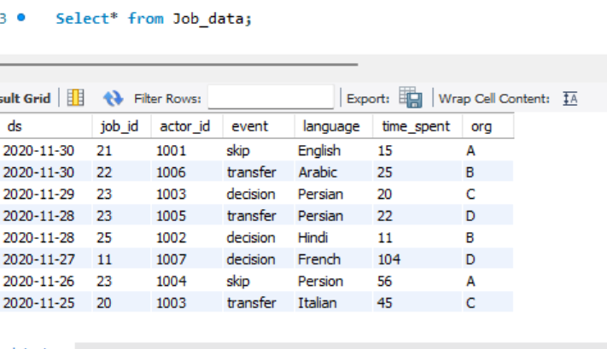

Tasks:
- Jobs Reviewed Over Time:
  - Objective: Calculate the number of jobs reviewed per hour for each day in November 2020.
  - Your Task: Write an SQL query to calculate the number of jobs reviewed per hour for each day in November 2020.
SELECT
ds AS review_date,
COUNT(job_id) AS total_jobs,
ROUND(COUNT(job_id) / 24, 2) AS jobs_per_hour
FROM
job_data
WHERE
ds BETWEEN '2020-11-01' AND '2020-11-30'
GROUP BY
ds
ORDER BY
ds;

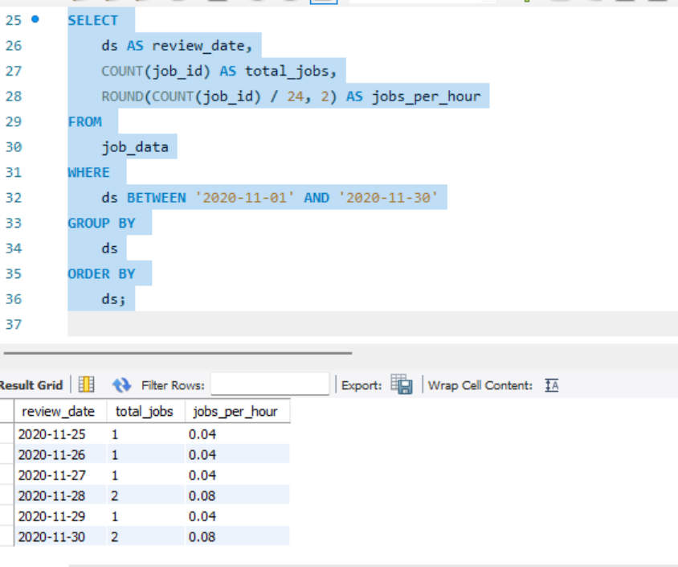

- Throughput Analysis:
  - Objective: Calculate the 7-day rolling average of throughput (number of events per second).
  - Your Task: Write an SQL query to calculate the 7-day rolling average of throughput. Additionally, explain whether you prefer using the daily metric or the 7-day rolling average for throughput, and why.
SELECT
ds AS review_date,
COUNT(job_id) AS daily_throughput,
ROUND(AVG(COUNT(job_id)) OVER (
ORDER BY ds
ROWS BETWEEN 6 PRECEDING AND CURRENT ROW
), 2) AS rolling_avg_throughput
FROM
job_data
GROUP BY
ds
ORDER BY
ds;
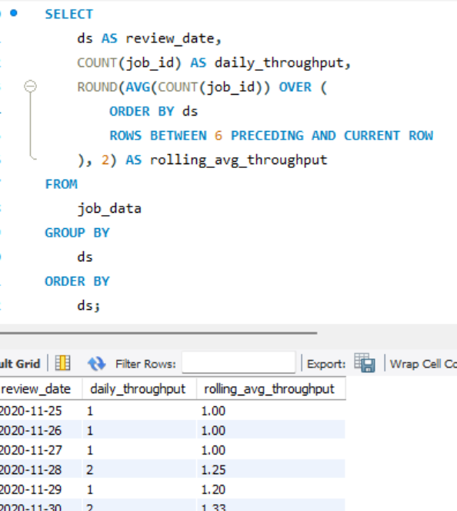

Definition:
Throughput = Number of jobs reviewed per day
7-Day Rolling Average = Average throughput of the current day and the previous 6 days

Terms and Terminologies
- 7-Day Rolling Average-
It is preferred for analysis. It is used for following reasons:
- Smooths out daily fluctuations: Workload can vary heavily day-to-day (weekends, holidays, batch jobs).
- Better trend visibility: Highlights overall performance trends without overreacting to single-day anomalies.
- Business insights: Helps management see consistent throughput capacity rather than reacting to daily spikes or drops.

- Daily Metrics-
It is used for daily analysis and good for monitoring. It is used for following reasons
- Useful for real-time performance tracking or operational monitoring.
- Highlights specific days where throughput was exceptionally high or low.

NOTE- For decision-making and trend analysis, the 7-day rolling average is better. It provides a balanced view of performance. For real-time operations or alerts, daily metrics make more sense.

- Language Share Analysis:
  - Objective: Calculate the percentage share of each language in the last 30 days.
  - Your Task: Write an SQL query to calculate the percentage share of each language over the last 30 days.

SELECT
language,
COUNT(*) AS language_count,
ROUND((COUNT(*) / (SELECT COUNT(*) FROM job_data WHERE ds BETWEEN '2020-11-01' AND '2020-11-30')) * 100, 2) AS percentage_share
FROM
job_data
WHERE
ds BETWEEN '2020-11-01' AND '2020-11-30'
GROUP BY
language
ORDER BY
percentage_share DESC;

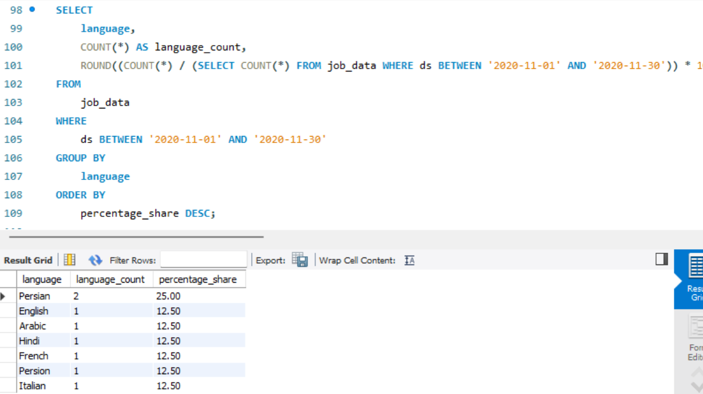

- Duplicate Rows Detection:
  - Objective: Identify duplicate rows in the data.
  - Your Task: Write an SQL query to display duplicate rows from the job_data table.

SELECT
ds, job_id, actor_id, event, language, time_spent, org,
COUNT(*) AS duplicate_count
FROM
job_data
GROUP BY
ds, job_id, actor_id, event, language, time_spent, org
HAVING
COUNT(*) > 1;

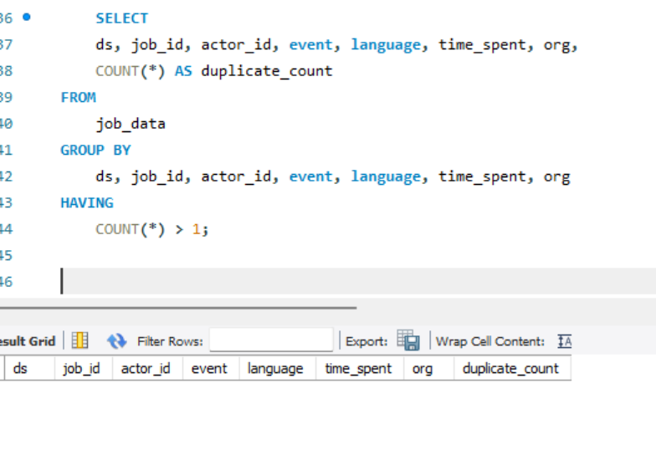

Note: Since there were no duplicates therefore the result columns are null

Case Study 2: Investigating Metric Spike
You will be working with three tables:
- users: Contains one row per user, with descriptive information about that user’s account.
- events: Contains one row per event, where an event is an action that a user has taken (e.g., login, messaging, search).
- email_events: Contains events specific to the sending of emails

For uploading the Data these queries are used
use project3;

SHOW VARIABLES LIKE 'secure_file_priv';

create table events(
user_id int,
occurred_at varchar(100),
event_type varchar(50),
event_name varchar(50),
location varchar(50),
device varchar(100),
user_type varchar(100)
);

LOAD DATA INFILE 'C:/ProgramData/MySQL/MySQL Server 8.0/Uploads/events.csv'
INTO TABLE events
FIELDS TERMINATED BY ','
ENCLOSED BY '"'
LINES TERMINATED BY '\n'
IGNORE 1 ROWS;

# The above is example of uploading of events file. Rest 2 were similarly uploaded

- Weekly User Engagement:
  - Objective: Measure the activeness of users on a weekly basis.
  - Your Task: Write an SQL query to calculate the weekly user engagement.

SELECT
user_id,
YEARWEEK(STR_TO_DATE(occurred_at, '%d-%m-%Y %H:%i:%s'), 1) AS year_week,
COUNT(*) AS total_events
FROM
events
WHERE
occurred_at IS NOT NULL AND occurred_at != ''
GROUP BY
user_id, year_week
ORDER BY
year_week, user_id;

Yearweek: returns the week number
Str_to _date: occurred_at was in varchar. Therefore to change string to date for operations
To find null values: if there is any null value then STR_to_Date silently gives null values

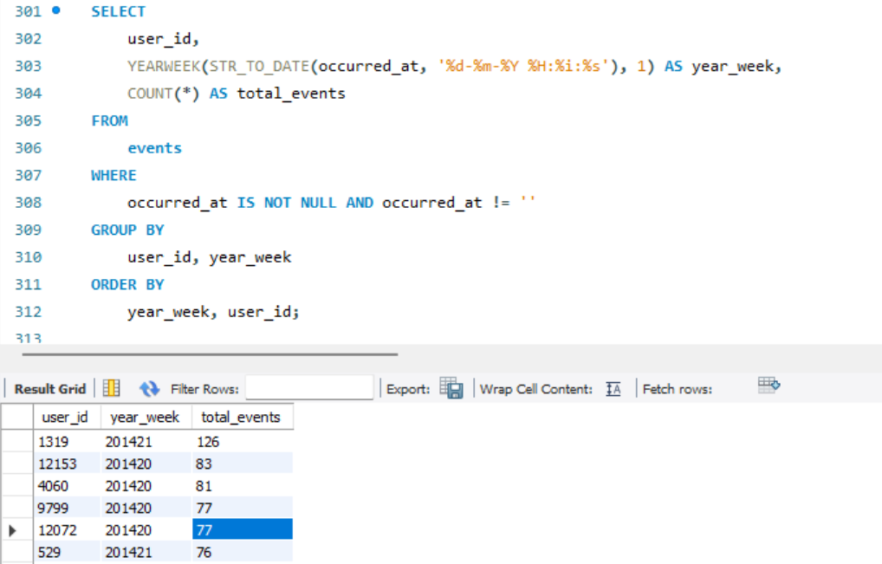
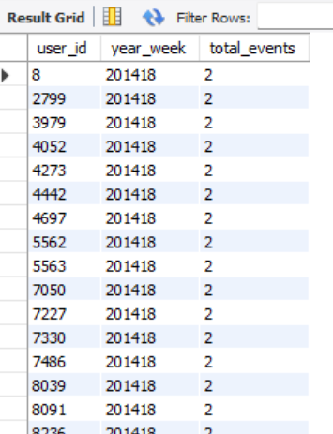
Insights and Interpretations:
- People are doing events in different locations
- User Id 1319 has done most events.
- Around 50 percent user has done less than 10 events in the given period of time

- User Growth Analysis:
  - Objective: Analyze the growth of users over time for a product.
  - Your Task: Write an SQL query to calculate the user growth for the product.

SELECT
DATE_FORMAT(STR_TO_DATE(created_at, '%d-%m-%Y %H:%i:%s'), '%Y-%m') AS month,
COUNT(user_id) AS new_users
FROM
users
GROUP BY
month
ORDER BY
month;
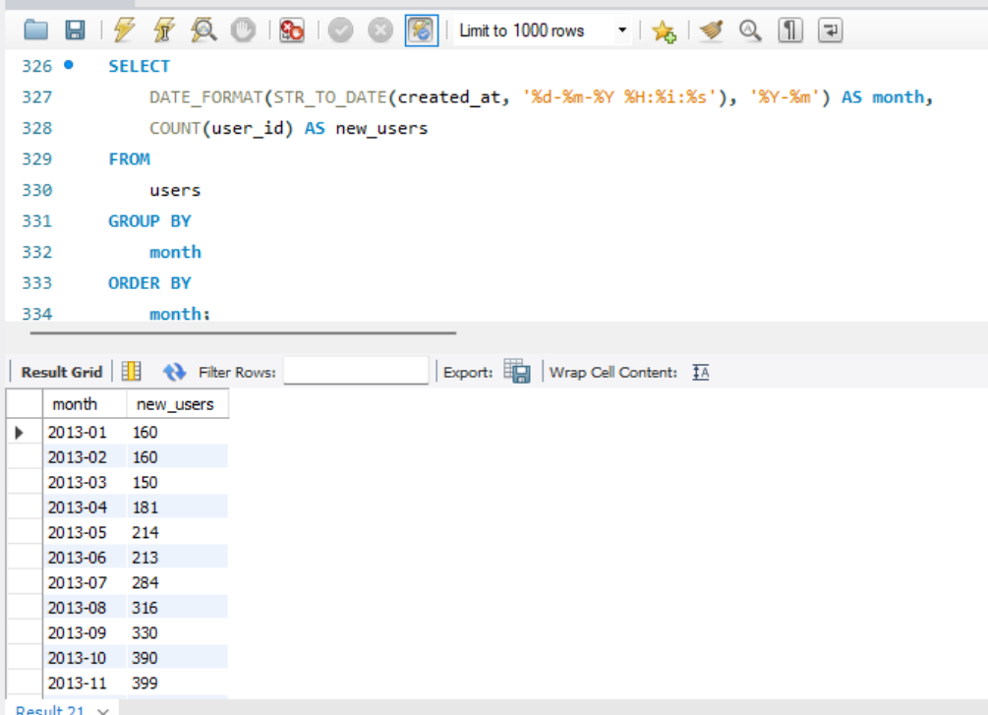
Insight and Interpretation: Month by Month new users are increasing

- Weekly Retention Analysis:
  - Objective: Analyze the retention of users on a weekly basis after signing up for a product.
  - Your Task: Write an SQL query to calculate the weekly retention of users based on their sign-up cohort.

WITH user_cohorts AS (
SELECT
user_id,
YEARWEEK(STR_TO_DATE(created_at, '%d-%m-%Y %H:%i:%s'), 1) AS signup_week
FROM users
),
user_activity AS (
SELECT
e.user_id,
YEARWEEK(STR_TO_DATE(e.occurred_at, '%d-%m-%Y %H:%i:%s'), 1) AS activity_week
FROM events e
)
SELECT
uc.signup_week,
ua.activity_week,
COUNT(DISTINCT ua.user_id) AS retained_users
FROM
user_cohorts uc
JOIN
user_activity ua ON uc.user_id = ua.user_id
WHERE
ua.activity_week >= uc.signup_week
GROUP BY
uc.signup_week, ua.activity_week
ORDER BY
uc.signup_week, ua.activity_week;
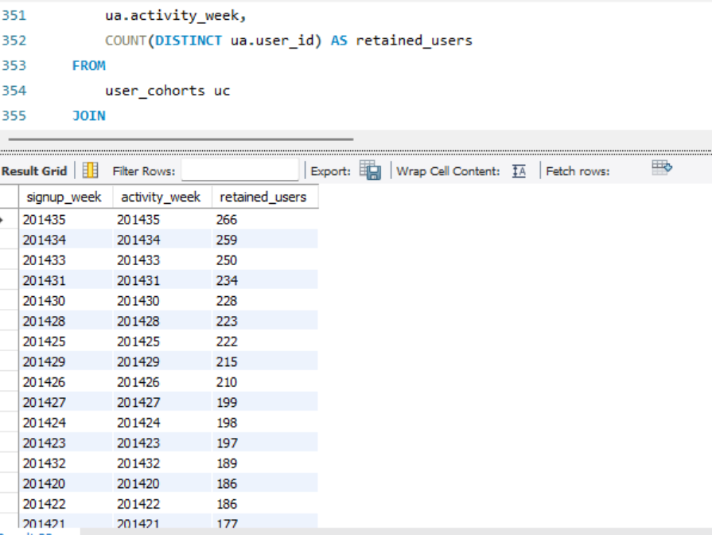
Insights and Interpretation: As per the screenshot, users’ retentions were increasing day by day. The activity was interesting and attracting people.

- Weekly Engagement Per Device:
  - Objective: Measure the activeness of users on a weekly basis per device.
  - Your Task: Write an SQL query to calculate the weekly engagement per device.

SELECT
YEARWEEK(STR_TO_DATE(occurred_at, '%d-%m-%Y %H:%i:%s'), 1) AS year_week,
device,
COUNT(*) AS total_events,
COUNT(DISTINCT user_id) AS unique_users,
ROUND(COUNT(*) / COUNT(DISTINCT user_id), 2) AS avg_events_per_user
FROM
events
WHERE
occurred_at IS NOT NULL AND occurred_at != ''
GROUP BY
year_week, device
ORDER BY
year_week, device;

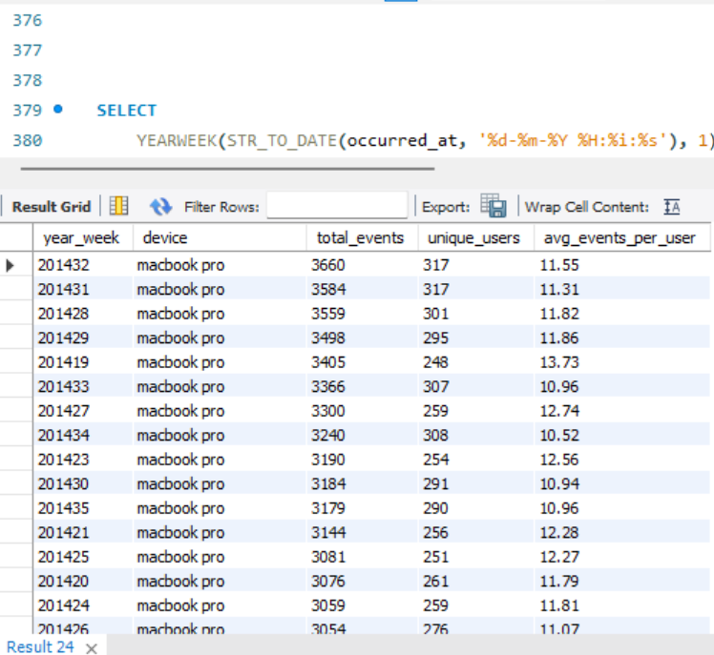
Insights and Interpretation:
- Macbook pro is highly used for the engagement. Might be it has many function or it is most available device in that country or area.
- Phones and tablets are used less.

- Email Engagement Analysis:
  - Objective: Analyze how users are engaging with the email service.
  - Your Task: Write an SQL query to calculate the email engagement metrics.
WITH email_metrics AS (
SELECT
COUNT(DISTINCT CASE WHEN action = 'sent_weekly_digest' THEN occurred_at END) AS total_emails_sent,
COUNT(DISTINCT CASE WHEN action = 'email_open' THEN occurred_at END) AS total_emails_opened,
COUNT(DISTINCT CASE WHEN action = 'email_clickthrough' THEN occurred_at END) AS total_emails_clicked
FROM
email_events
)
SELECT
total_emails_sent,
total_emails_opened,
total_emails_clicked,
ROUND((total_emails_opened * 100.0 / total_emails_sent), 2) AS open_rate,
ROUND((total_emails_clicked * 100.0 / total_emails_sent), 2) AS click_through_rate,
ROUND(((total_emails_opened + total_emails_clicked) * 100.0 / total_emails_sent), 2) AS engagement_rate
FROM
email_metrics;

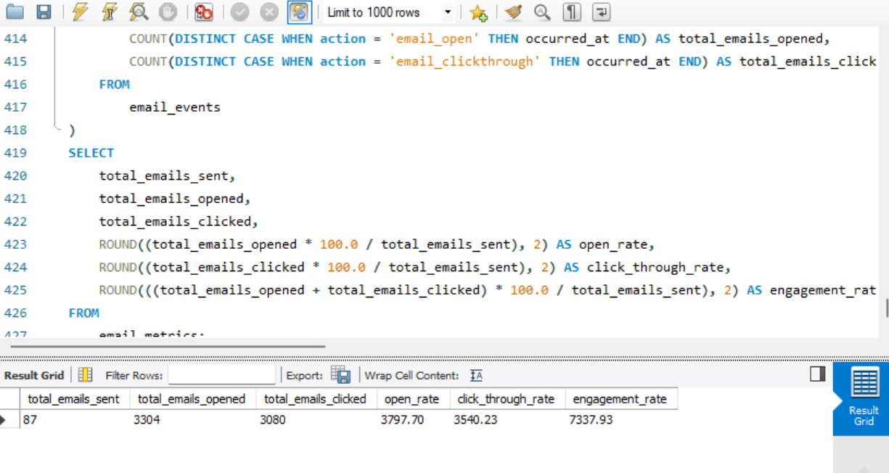

Insights and Interpretation: The campaign was more successful through email engagement than click through. So we can go for email engagement more.

Project Description
The project focuses on analyzing job data and user engagement metrics to optimize workflows and improve decision-making. The analysis involves SQL queries to calculate throughput, language share, user growth, and email engagement.

Approach
The analysis was executed using SQL queries to extract, aggregate, and analyze data. Key metrics like throughput, user engagement, and retention were calculated to identify trends and patterns.

Tech-Stack Used
MySQL Workbench was used for querying and analyzing the data. It enabled efficient data manipulation, aggregation, and visualization for deriving actionable insights.

Insights
Key insights include the preference for 7-day rolling averages for trend analysis, higher engagement on MacBook Pro devices, and successful email campaigns with high engagement rates.

Result
The project enhanced understanding of job review processes and user engagement trends, enabling data-driven decisions to optimize workflows and improve user retention.

